


Greif Poland Technical Specification

for the following bottles:

0-04-0770-6-00-000-X

Greif Poland Sp. z o. o.
Ul. Przemysłowa 3
44-203 Rybnik

tel. +48 32 42 95 040
fax. +48 32 42 95 041

Greif Poland Technical Specification

for the following bottles:

0-04-0770-6-00-000-X

- Requirements of quality.
- Marks on a bottle.
- Requirements of labelling.
- Labelling of packages, description of code.
- Producer’s recommendation.
- Nr of batch.

Ad. pkt. 1. Requirements of quality.

- Appearance:

- Clean, without damages and any contaminations.
- Neck processing, neck trimming, smooth upper and bottom joints.
- Blue colour, uniform, transparent, attachment no. 1a.
- Careful labels application.

- Dimensions:
- Bottle height 488 (+/ - 3 mm), attachment no. 1b.
- Bottle diameter 272 (+/ - 2 mm), attachment no. 1b.
- Bottle capacity 18,9l (+/ - 0, 25 %).
- Outside neck diameter 55, 30 (+/ - 0, 45), attachment no. 1b.
- Bottle weight 770g (+ / - 25 g.), attachment no. 1b.

Ad. 2 Marks on a bottle.

Attachment no. 2.

Ad. 3 Requirements of labeling.
- Attachment no. 3.

Ad. 4 Labelling of packages, code explanations.

Attachment no. 4.

Ad. 5 Producer’s recommendation.
- Attachment no. 5.

Ad. 6 Batch’s description.
- Bottles produced at the same time, on two separate production lines have different batch numbers.
- Bottles produced on one line, from the same Polycarbonate batch in a continuous way have the same batch number.
  - In case of stopping the production and restarting, a new batch number is assigned.

Attachment no.1a

Assesment criteria of bottles’ transparency

36-Not Approved
28 – Not Approved
24 – Not Approved
18 – Not Approved
16 – Not Approved
14 – Not Approved
12 – Approved
10 – Approved
8 – Approved
6 – Approved

Attachment no. 1b

Attachment no. 2

Marks on a bottle

Day of production

Month of production
Shift number

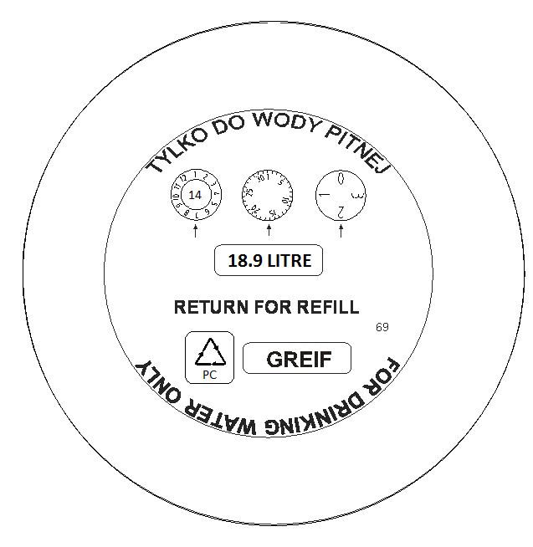
Year of production
Type of raw material
Mould number (e.g. 36/ 41/ 63/ 64/ 69/ 71)

Attachment no. 3

Attachment no. 4

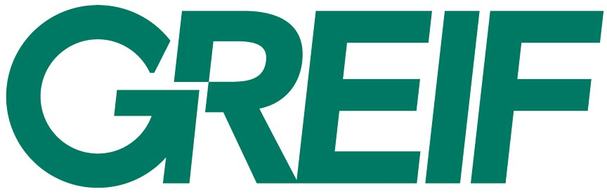

Product no.:
0-04-0770-6-00-000- X
Internal order no.:
SFC 03808
Palette no: Batch
1 z 108 200001
Palette type:
27

Product no. (description):
- Type of material (Polycarbonate).
04- Bottle 18,9l. four ribs with handle.
0770- Bottle weight (decagram).
6- Neck type.
- Insert (catalogue number).
000- Label (catalogue number).
X - bottles in single packaging.

X - Packaging type:
0 – 9 bottles in single packaging
1 – 4 bottles in single packaging
2 – 8 bottles in single packaging
3 – 27 bottles in single packaging
4 – 52 bottles in single packaging
5 – 60 bottles in single packaging
6 – 88 bottles in single packaging
8 – 72 bottles in single packaging
9 – 18 bottles in single packaging

- - 9 bottles in single packaging
- - 4 bottles in single packaging
- - 8 bottles in single packaging
- - 27 bottles in single packaging
- - 52 bottles in single packaging
- - 60 bottles in single packaging
- - 88 bottles in single packaging
- - 72 bottles in single packaging
- - 18 bottles in single packaging

- - 9 bottles in single packaging
- - 4 bottles in single packaging
- - 8 bottles in single packaging
- - 27 bottles in single packaging
- - 52 bottles in single packaging
- - 60 bottles in single packaging
- - 88 bottles in single packaging
- - 72 bottles in single packaging
- - 18 bottles in single packaging

Internal order number e.g. SFC 03808.
Palette number e.g.. 1,2,3…of 108.

Palette type e.g. 27.
Batch number e.g. 20001.
SFC 03808 Greif order number.
1,2,3…- Packaging number
108- Number of packaging within order.
27- Quantity of bottles in single packaging.
20001- Next batch number.

Attachment no. 5

DEAR CUSTOMER

We herby inform that Polycarbonate bottles purchased in Greif Poland should be disinfected and rinsed precisely before each use.
The washing and sterilizing detergents should have the proper certificates and should be used according to the procedures recommended by their producers.

Insert
Label
Type of packaging
Insert
Label
Type of packaging

